Replication set

- Install mongodb(refer this link )
- Create config file
Desc: first we assume that have 3 instance of mongodb, and the detail of configuration
as below

Instance 1 | Instance 2 | Instance 3
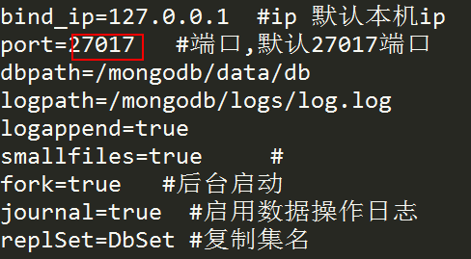 | 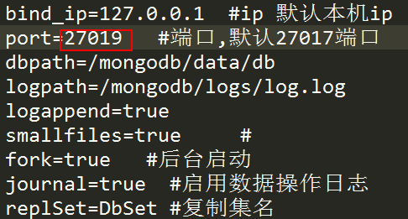 | 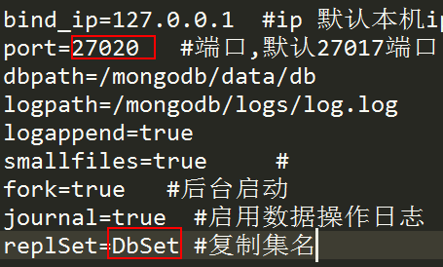

As above the repla set name is DbSet and the bind port is 27017 , 27019 , 27020

- Start all of instances

mongod -f mongod1.conf # start mongo instance 1 with port 27017
mongod -f mongod2.conf # start mongo instance 1 with port 27019
mongod -f mongod3.conf # start mongo instance 1 with port 27020

- Config mongo

4.1 Connection to one of mongo instance for example : 2701
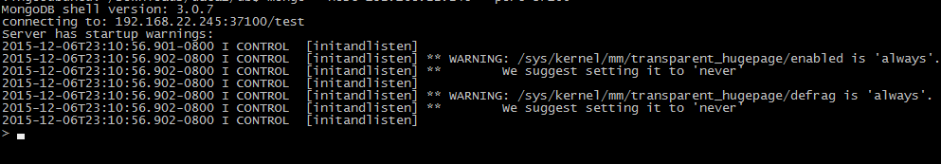

4.2 define a attr called config and the vaule is
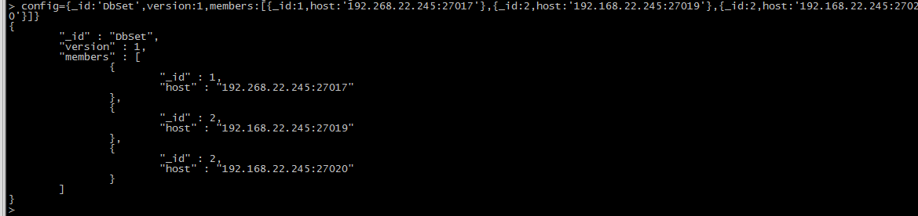
4.3 init replication set config
rs.initiate(config)

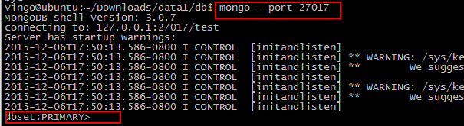
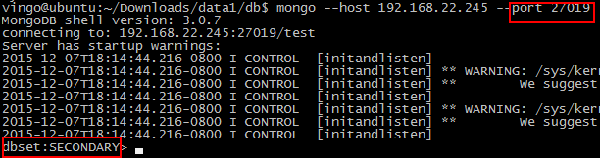

*Extra method
rs.add #add an instance
rs.remove #remove an instance
rs.status() #search repl set status
rs.conf #search config
rs.stepDown #change currently master to secondary
rs.reconfig #update config property

